How to use LED control feature of Powerline Extender?
Step 1: Open the browser and input plc.tendawifi.com in address bar to login setup page. By default, password is “admin”.
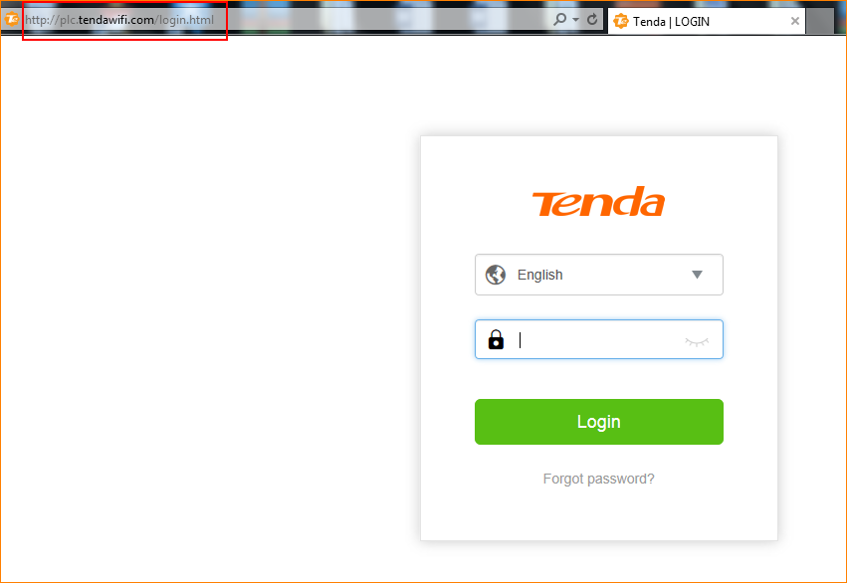

Step 2: Choose “System” > “LED Control”.

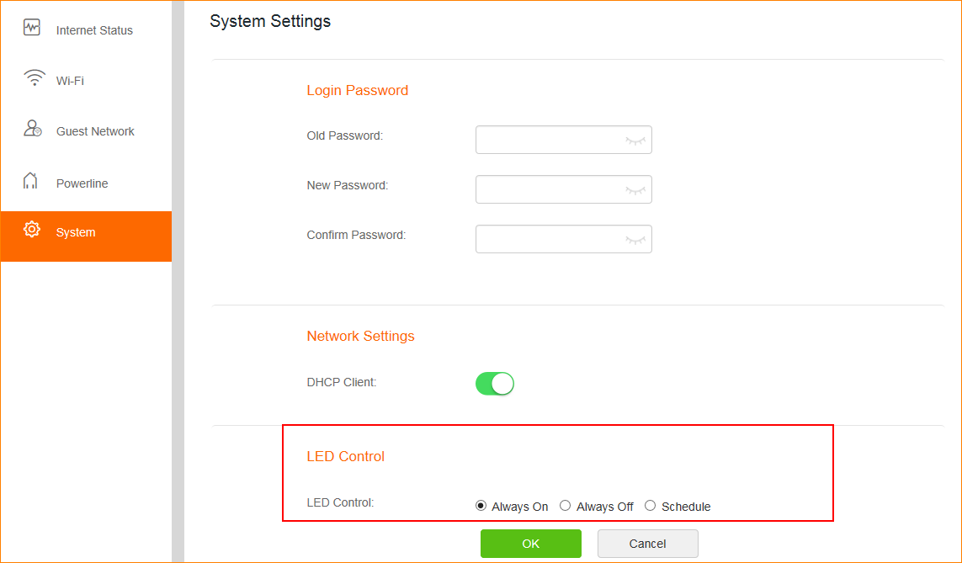

Note: If you choose “Schedule”, please follow the instruction to finish the settings and tap “OK” to save the settings.
